Rams
Pootatuck Yacht Club
Super Bowl Party
Patriots

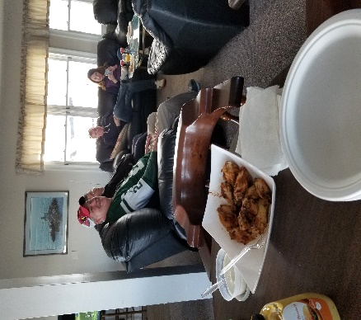
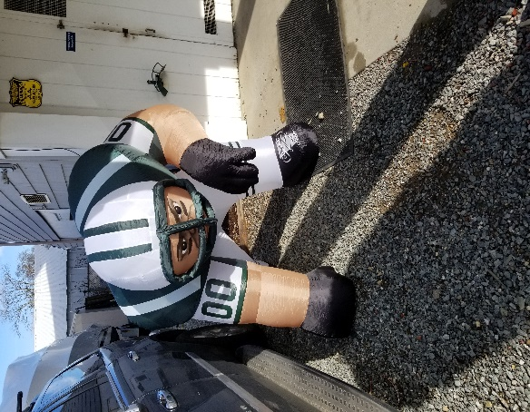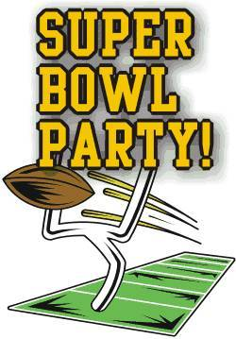

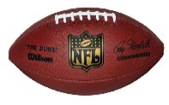
This Photo by Unknown Author is licensed under CC BY-SA-NC
Super Bowl Sunday – February 3, 2019
Tailgate “Clubgate” Starts at 5:00pm (on the patio, porch & 2nd Floor)
Kickoff: 6:30pm
Place: Pootatuck Stadium - Mezzanine Section (second floor LOL)
Cost: FREE EVENT
Potluck Gathering – Please bring your favorite tailgating food &/or dessert to share
BYOB, Water & Soda
50/50 raffle (I need someone to run this part of the event)
Invite a few friends!
________________________________________________________________________

Please RSVP to Richard via e-mail to rich.schausmktg@earthlink.net by Jan 30th, 2019

We need some help cleaning up after this event so please let me know if you can help

Both kitchens will be closed due to the party the night before

I will be making HOT Wings in my air-fryer and pre-game hot dogs - we could use chili, finger food, pizza, BBQ, pulled pork, etc. If anyone wants to make a pitcher of Bloody Mary’s, Irish Coffee or Hot Spiked Cider…it would be welcomed by most of us lol.

Please remember to bring cooking/eating utensils, bowls & platters, etc.

The club will supply plates & cups.

Anyone with portable patio heaters for those that want to brave the cold for the tailgate on the patio can bring them.

Thanks Barbara & Richard

