

Pootatuck 2024 Fall Picnic
September 7, 2024
Breakfast 9:30 at Yacht Club
Lunch all day, Dinner at 5:30 PM
Please join us for the annual Picnic!

Invite your family, friends and neighbors, and join the FUN Be sure to stick around for the 50/50 raffle!
Food & Beverage:
Breakfast: Eggs, Bacon, Liver, Onions
Lunch: Hamburgers, Hot Dogs, Clam Chowder, Clams on the half shell, Chili, Wine, Beer & Soda
Dinner: Salad, Corn, Baked Potatoes, Steak, Lobster, Desert, Coffee

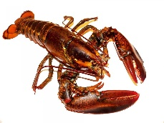
Members free (choice of steak or lobster)
Members wanting both is a $20 charge
Family & Friends $55 (choice of steak or lobster)
Family & Friends $65 (steak AND lobster)
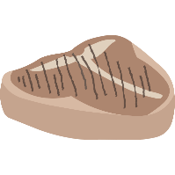
Children 12 & Under $25 (choice of steak or lobster) Children Under 6 free (without steak or lobster)

Sorry due to increased cost of food, this is by RESERVATION ONLY Absolutely no “walk-ins”, NO EXCEPTIONS
Please RSVP by Tuesday September 3rd
Ian Bass 203-981-4800 or ianbass123@gmail.com
With name, # of people, and dinner choice

Kids fishing – 9 AM (see Ralph for more information)
Cardboard boat races – 2 PM (see Marti or Amanda for more information)

